

Introduction to the Microscope

OVERVIEW
Follow along in this online exercise, with guided instruction covering the basics of light microscopy, comparable to
what you would learn in a seated lab. You will identify components of the microscope, understand the functions of those components, learn how to focus in on a specimen, and review proper care and maintenance.

LEARNING OBJECTIVES
- Identify the parts of the light microscope and describe the function of each.
- List the steps in focusing a light microscope.
- Describe how to properly handle the light microscope, focus slides, and clean the microscope when finished.

BACKGROUND
When we walk out the door each day we see many examples of life on earth – trees, birds, other humans. Unless we look closer we will miss the huge diversity of life that is too small to be seen with our eyes alone. The majority of life on earth is microscopic and, until tools were available to visualize these organisms, they were completely overlooked. One of the first tools that opened our eyes to microbial life was the microscope. The light microscope uses lenses along with light to magnify items up to 1000x. This allows us to see organisms like bacteria, archaea, yeasts, protozo- ans, and algae that we would never notice because they are so small. In addition, we can also look closer to see cells that are the building blocks of the macroscopic organisms (like ourselves, the trees, and birds we noticed earlier.)

In addition to magnifying organisms, most cells are colorless so many times preparing slides also involves adding stains (dyes) to color the cells so they are more easily viewed. The slides you will practice with today are either naturally pigmented or have been stained so we can find them more easily. Look for these colors as you are focusing the virtual microscope.

THE MICROSCOPE AND YOUR EYES
Students often wonder if they should remove their glasses when using a microscope. If you are nearsighted or farsighted, there is no need to wear your glasses. The focus adjustments will compensate. If you have astigmatism, however, you should wear your glasses because microscope lenses do not correct for this problem. You should still wear your glasses when working with the virtual microscope.



PROCEDURE 1: Introduction to the Microscope and its Parts
- Go to http://www.ncbionetwork.org/iet/microscope/.
- Click on the Guide link ( bottom of the home page ).
- Click through the six parts of the Guide, starting with the Introduction. You can use the arrows at the bottom of the Guide box to guide you through the chapters.
- When you have completed all six sections, click Close.
- Next click on the Learn link (bottom of the page), which will take you to an image of a microscope with question marks.
- Starting at the top of the microscope, click on the question marks identifying the parts of the microscope.
- Read the description of the part of the microscope and take notes as needed.
- Continue clicking on question marks until all turn to green check marks.
  - Do not forget to click on the question marks for items associated with the microscope.
  - You may click on any green check mark to review any part of the microscope.
  - Use the Microscope Parts checklist on the next page to ensure all parts have been identified.
- Click on the Next button (bottom right).
- Start on the left and click on the question mark. When the lens enlarges, click on each question mark until each turns into a green check mark. Read the descriptions and take notes as needed.
- Click on the Next button (bottom right).
- Click on the Dry Slide and Oiled Slide buttons to see the difference in why immersion oil is used for the 100X objective lens.
- Click on the Next button ( bottom right ).
- Click on the Eyepiece Options and Lens Options to learn about calculating total magnification. Try all combinations and see how the Letter E slide image changes.
- Click on the Next button (bottom right) to return to the home page.
- Answer the provided questions on the next page.

*Be aware! Depending on its age, manufacturer, and cost, in a laboratory a compound microscope may have only some of the features discussed in this section.



MICROSCOPE PARTS
Identify all parts of the microscope and associated items.
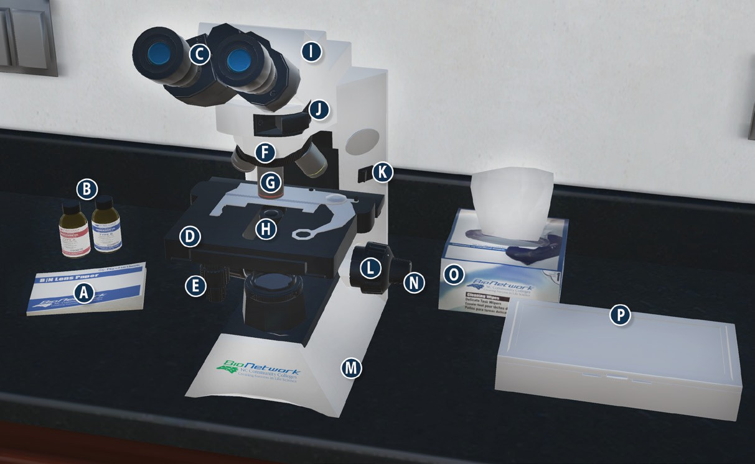
On/ Off switch Eyepiece/ Ocular lens
Arm Nosepiece
Objective lenses Stage
Diaphragm Stage adjustment knob
Base Coarse adjustment knob
Lens paper Fine adjustment knob
Immersion oil Slide/ slide box
Kimwipes

QUESTIONS
- What is the proper way to carry a microscope?

- What is the typical magnification of an ocular lens? What other magnifications are possible?

- What are the magnification abilities of each of the objective lenses? What is the total magnification with each objective?
  - Scanning ( small lens ), red ring =
  - Low-power ( medium lens ), yellow ring =
  - High-power ( large lens ), blue ring =
  - Oil immersion ( largest lens ), white ring =

- Why do you use immersion oil with 100X objective lens?

- What is the total magnification of a sample with an ocular lens power of 15X and using a 40X objective lens?

- What is a diaphragm? What does it do?



PROCEDURE 2: How to use a compound microscope to view slides
- Click on the Explore link ( bottom of the home page ).
- Click on the question mark on the slide box.
- In the Slide Catalog, click on the Sample Slides.
- Click on the Letter E slide. It will automatically be placed on the stage of the microscope.
- When the Microscope View window opens, make sure that the 4X circle is highlighted in blue.

NOTE: Always begin examining slides with the lowest power objective.
- Use the slider under Coarse Focus to find the E.

NOTE: The coarse adjustment knob should only be used when you are viewing a specimen with the 4X objective lens.
- Then use the slider under Fine Focus to make the image “crisp and clear.”
- You can click on the E in the viewing window to move the image and visualize different parts. Sketch your view of the letter E at 4X in the results area.
- Next click on the 10X circle. The nosepiece on the microscope will rotate automatically.
- Repeat steps 6 – 8 to see part of the E. Sketch your view of the letter E at 10X in the results area.
- Click on the 40X circle and repeat steps 7 & 8. You may need to use the slider under Light Adjustment for better visualization. Sketch your view of the letter E at 40X in the results area. Click on the 100X circle.
A notice to add immersion oil will open.
- Click on the question mark on the immersion oil bottles to add oil to the microscope.
- Repeat steps 7 & 8. You may need to use the slider under Light Adjustment again for better visualization. Sketch your view of the letter E at 100X in the results area.
- When you have visualized the Letter E slide using all 4 objective lenses, click on Remove Slide ( top right ).
- Read the notice about using lens paper to clean the immersion oil off the microscope and click on the
question mark over the lens paper. Choose wisely!
- Click on the Main button ( bottom left corner ) to return to the home page.



RESULTS: Sketch the letter “e” at each of the resolutions

Letter “e” at 4X Letter “e” at 10X Letter “e” at 40X Letter “e” at 100X

QUESTIONS
- What did you notice about the letter E when you increased in magnification from the 4x to the 10x and then to the 40X:
  - Did the size (magnification) increase or decrease?
a) Could you see more of the entire letter or less?

KNOWLEDGE CHECK
- Click on the Test button (bottom of home page).
- In the Challenge Mode window, click on Care & Usage link and answer the questions.
- If you get a 75% or better, click Choose Test. If you do not get a 75% or better, click Try Again.
- Next choose the Calculating Magnification link and repeat #3.
- Then choose the Terminology link and repeat #3.
- Click on the Main button ( bottom left corner ) to return to the home page.

